**PRODUCT DEMAND PREDICTION WITH MACHINE LEARNINGS**

PHASE-3 Development Part-1

**SUBMITTED BY :**

**Thammineni Naveen Kumar**

**au723921104048**

[**naveenravana89@gmail.com**](mailto:naveenravana89@gmail.com)

**Project** : PRODUCT DEMAND PREDICTION WITH MACHINE LEARNINGS

**Phase-3** :**Development Part-1**

**Topic : In this part you will begin building your project by loading and preprocessing the dataset.**

**INTRODUCTION:**

Predicting product demand using machine learning involves utilizing algorithms and historical data to forecast future demand for a specific product. introduction to the process: Data Collection and PreparationGather historical data related to the product, including sales, customer demographics, seasonality, marketing efforts, and any other relevant factors. Clean and preprocess this data to remove errors, outliers, or inconsistencies.Feature Engineering: Identify meaningful features from the data that could impact product demand, such as pricing, promotions, time of year, economic indicators, orcustomer behavior. These features will serve as inputs for the machine learning model. Model Selection:Choose an appropriate machine learning model based on the problem, data, and desired prediction accuracy. Common models for demand prediction include regression models, time series models (e.g., ARIMA, SARIMA), decision trees, random forests, and neural networks.

Model Training:Train the selected model using a portion of the historical data. The model learns to recognize patterns and relationships between the chosen features and product demand.Model Evaluation: Assess the model's performance using validation data. Common evaluation metrics include Mean Absolute Error (MAE), Mean Squared Error (MSE), or R-squared, which quantify the accuracy of predictions.

Hyperparameter Tuning: Optimize the model's hyperparameters to enhance its performance. Hyperparameters are settings that influence the model's behaviour and can be adjusted to improve prediction accuracy. Prediction and Forecasting Use the trained and validated model to make predictions on future data, projecting the product demand for specified time periods. These forecasts can guide inventory management, production planning, and marketing strategies. Continuous Improvement: Periodically retrain and update the model with new data to ensure its relevance and accuracy in predicting product demand as market dynamics change

GIVEN DATASET :

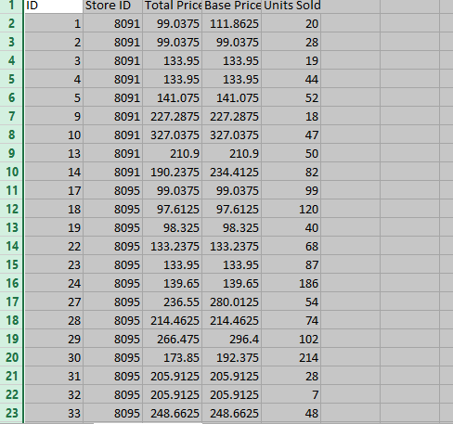

Importance of Loading and preprocessing datasets :

Loading and preprocessing datasets are crucial steps in product demand prediction with machine learning.

⚫Data Integrity and Consistency:

Loading ensures the data is properly read into the system, maintaining its integrity and consistency for accurate analysis.

⚫Data Understanding:

Preprocessing involves exploring and understanding the data, identifying missing values, outliers, and inconsistencies that may impact prediction models.

⚫Feature Engineering:

Preprocessing allows for feature extraction, transformation, and selection, enhancing the quality and relevance of features for predicting product demand.

⚫Normalization and Scaling:

Preprocessing aids in normalizing and scaling features, ensuring uniformity and preventing bias towards certain features during model training.

⚫Handling Missing Values:

Preprocessing addresses missing data through imputation or removal, enabling effective utilization of available information.

⚫Dealing with Categorical Data:

Conversion of categorical variables to numerical representations facilitates their integration into machine learning models.

⚫Dimensionality Reduction:

Techniques like PCA or feature selection help in reducing the dataset's dimensions while retaining essential information, improving model efficiency and performance.

⚫Data Splitting:

Preprocessing often involves dividing the dataset into training, validation, and test sets, ensuring an unbiased evaluation of the model's performance.

loading and preprocessing datasets pave the way for cleaner, more meaningful data, ultimately enhancing the accuracy and effectiveness of machine learning models in predicting product demand

**Python Program :**

import numpy as np

import pandas as pd

import matplotlib.pyplot as plt

import seaborn as sns

data = pd.read_csv("Historical Product Demand.csv")

data

data.head(10)

data.tail(10)

data.isna().sum()

data.dropna(axis = 0, inplace = True)

data.isna().sum()

data.describe(include= 'all')

data1 = pd.read_csv("PoductDemand.csv")

data1

data1.mean()

data1.corr()

sns.heatmap(data1.corr())

plt.show()

plt.boxplot(data1)

data1.groupby('Units Sold').corr()

from sklearn import preprocessing

sc = preprocessing.LabelEncoder()

from sklearn.preprocessing import MinMaxScaler

le = MinMaxScaler()

le.fit(x)

from sklearn.model_selection import train_test_split

x_train, x_test, y_train, y_test = train_test_split(x, y, test_size = 0.25, random_state = 50 )

**ARCHITECTURE OF PRODUCT DEMAND PREDICTION :**

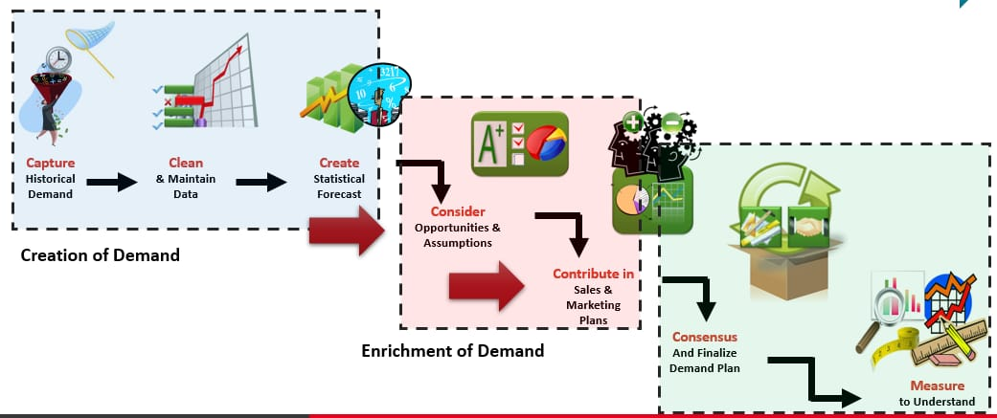

**EXPLANATION :**

Product demand prediction involves using data and statistical techniques to forecast the future demand for a product. This prediction helps businesses make informed decisions regarding production, inventory, and marketing strategies. Several steps are involved in creating a demand prediction modelData Collection: Gather historical sales data, customer preferences, market trends, economic indicators, and any other relevant data sources.

Feature Engineering: Identify and create relevant features (variables) that could impact product demand, such as price, promotions, seasonality, or marketing activities.Model Selection: Choose a suitable predictive model, such as regression, time series analysis, machine learning algorithms (e.g., decision trees, neural networks), or advanced forecasting techniques. Training the Model: Use historical data to train the chosen model, where the model learns the relationships between features and product demand. Validation and Testing Assess the model's performance using validation datasets or techniques like cross-validation to ensure it accurately predicts demand.

Parameter Tuning: Optimize the model by adjusting parameters to achieve the best predictive performance. Forecasting: Apply the trained and validated model to future data to generate predictions for product demand. Evaluation: Evaluate the model's predictive accuracy using metrics like Mean Absolute Error (MAE), Root Mean Squared Error (RMSE), or others suitable for the specific problem. Implementation and Monitoring: Implement the model in the business operations and continually monitor and update the model to adapt to changing market dynamics. By accurately predicting product demand, businesses can optimize their supply chains, manage inventory efficiently, plan marketing campaigns effectively, and ultimately improve their overall business strategy.

CONCLUSION:

**Conclusion leveraging machine learning for product demand prediction offers significant potential for businesses. By analyzing historical data and utilizing advanced algorithms, accurate demand forecasts can be generated, aiding in informed decision-making, optimized inventory management, and enhanced customer satisfaction. However, it's crucial to continually refine and update models, incorporate new data sources, and consider market**

**dynamics to ensure the predictions remain reliable and effective in a dynamic business environment.**